**LAB-2**

**Instructions:**

* Uploaded the file with questions in MS TEAM
* Complete all the programs, put the code, input and output Screenshots in a single file.
* File name should be your **registerno**_**lab2 eg 18ABC1234_LAB2.doc**
* Upload it in assignment ->LAB1 in MS TEAM

**NAME:**

**REGNO:**

**LAB: CSE4002 Mobile Application Development LAB**

**Questions:**

1. Design the following APP for the IOT store. The cost of Aurdino Uno is 500RS, the cost of WIFI module is 250RS and the Bluetooth module is 200RS. Based on the quantity compute the Amount payable whrn submit button is clicked, When clear is clicked clear all the Editboxes.

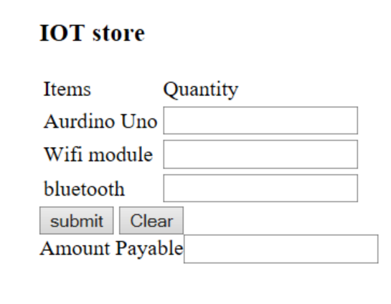

1. Design a Currency converter App. 1 RS=

